**Objects and its internal representation in JavaScript.**

**Objects:**

A JavaScript object is a real-world entity having state and behavior (properties and Method). object is a collection of data in the form of **“key: value”** pairs. Objects are represented by defining its properties along with their values.

**Ways of representing objects:**

**Using object literals:**

The properties and values of object are inserted between curly braces.

//creating js objects with object literal

let bike = {

    name: 'Ducati',

    color: 'red',

    price: 35000,

    self-start: function(){

        console.log("Bike starts");

    }

};

//property accessor

console.log(bike.color); //dot notation

console.log(bike['price']); //bracket notation

In the above bike object, we can see the properties name, color and price along with their values and function are represented inside object literals.

If we want to access the properties inside the bike object, we can access them by using dot and bracket notation.

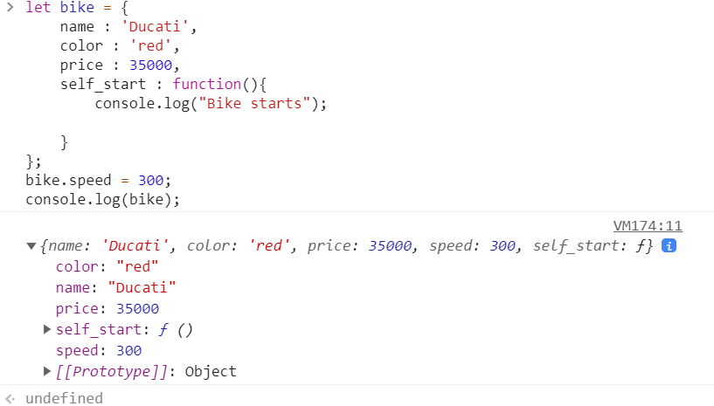

Here we can see adding new property to defined object, for defined bike object we added new property speed. Likewise, we can add new function as well.

**Creating object with constructor:**

The constructor is a special function for creating and initializing objects within a class. Constructor gets invoked using the new keyword. Constructor allows us to create multiple objects of same types.



Here we can see constructor(device) having parameters price, brand and OS parameters. With the help of new keyword, we can create multiple objects having similar parameters.

**Creating object with object.create() method:**

The Object.create() method creates a new object, using an existing object as the prototype of the newly created object.

**Syntax :**

Const newobject = Object.create(prototype, newproperties)

let human = {

    height: "6ft",

    maxheight: "8ft"

}

let person = Object.create(human,

    {

    name: {

        value: "Vamsi",

       age: 25

    }

});

console.log(person.height);

console.log(person.name);



Here the person object inherits the properties of human object by using object.create()

Method and person object has its own properties as well.

Person object has inherited the properties height and maxheight of human object.